“If you’re offered a seat on a rocket ship, don’t ask what seat. Just get on!” –Sheryl Sandberg

BY GEORGE MAVROEIDIS

A ROCKET’S MOVEMENT IN SPACE

George Mavroeidis 1559858 Statics and Engineering Physics 203-HTK-05 section 00002 Professor Jicai (James) Pan 8 of May 2017

Table of Contents:

1. **Abstract** . . . . . . . . . . . . . . . . . . . . . . . . . . . . . . . . . . . . . . . . . . . . . . . . . . . . . . . . . . . . . . . . . .2-3
2. English Version . . . . . . . . . . . . . . . . . . . . . . . . . . . . . . . . . . . . . . . . . . . . . . . . . . . . . . . . . . . . .2
3. French Version . . . . . . . . . . . . . . . . . . . . . . . . . . . . . . . . . . . . . . . . . . . . . . . . . . . . . . . . . . . 2-3
4. **Introduction** . . . . . . . . . . . . . . . . . . . . . . . . . . . . . . . . . . . . . . . . . . . . . . . . . . . . . . . . . . . . . . 4-6
5. Rocket Definition . . . . . . . . . . . . . . . . . . . . . . . . . . . . . . . . . . . . . . . . . . . . . . . . . . . . . . . . . . .4
6. History of Rockets . . . . . . . . . . . . . . . . . . . . . . . . . . . . . . . . . . . . . . . . . . . . . . . . . . . . . . . . 4-5
7. Uses of Rockets . . . . . . . . . . . . . . . . . . . . . . . . . . . . . . . . . . . . . . . . . . . . . . . . . . . . . . . . . . . . 5
8. Assessment’s Focus . . . . . . . . . . . . . . . . . . . . . . . . . . . . . . . . . . . . . . . . . . . . . . . . . . . . . . . 5-6
9. **Theoretical Foundations** . . . . . . . . . . . . . . . . . . . . . . . . . . . . . . . . . . . . . . . . . . . . . . . . . 7-26
10. Forces, Acceleration and Gravity . . . . . . . . . . . . . . . . . . . . . . . . . . . . . . . . . . . . . . . . . . . . . . 7
11. Gravitational Force . . . . . . . . . . . . . . . . . . . . . . . . . . . . . . . . . . . . . . . . . . . . . . . . . . . . . . . 7
12. Normal Force . . . . . . . . . . . . . . . . . . . . . . . . . . . . . . . . . . . . . . . . . . . . . . . . . . . . . . . . . . . . 8
13. Thrust Force . . . . . . . . . . . . . . . . . . . . . . . . . . . . . . . . . . . . . . . . . . . . . . . . . . . . . . . . . . 8-10
14. Drag Force . . . . . . . . . . . . . . . . . . . . . . . . . . . . . . . . . . . . . . . . . . . . . . . . . . . . . . . . . . 11-13
15. Lift Force . . . . . . . . . . . . . . . . . . . . . . . . . . . . . . . . . . . . . . . . . . . . . . . . . . . . . . . . . . . .13-14
16. Kinematics of Rocket Trajectory . . . . . . . . . . . . . . . . . . . . . . . . . . . . . . . . . . . . . . . . . . . 15-20
17. First equation . . . . . . . . . . . . . . . . . . . . . . . . . . . . . . . . . . . . . . . . . . . . . . . . . . . . . . . .15-17
18. Second Equation . . . . . . . . . . . . . . . . . . . . . . . . . . . . . . . . . . . . . . . . . . . . . . . . . . . . . .17-18
19. Third Equation . . . . . . . . . . . . . . . . . . . . . . . . . . . . . . . . . . . . . . . . . . . . . . . . . . . . . . . 19-20
20. Tsiolkovsky (Ideal) Rocket Equation . . . . . . . . . . . . . . . . . . . . . . . . . . . . . . . . . . . . . . . . 21-25
21. **Conclusion** . . . . . . . . . . . . . . . . . . . . . . . . . . . . . . . . . . . . . . . . . . . . . . . . . . . . . . . . . . . . . .26-27
22. **References** . . . . . . . . . . . . . . . . . . . . . . . . . . . . . . . . . . . . . . . . . . . . . . . . . . . . . . . . . . . . . .28-29
23. ***ABSTRACT***
    1. ***Abstract (English Version):***

The basis of this comprehensive assessment was to examine the fundamental concepts of a basic heavy-lift ballistic spaceflight rocket launched from a rocket silo. Classic Mechanics was the tool used to analyze the rocket’s movement and interaction with space. This study starts with the basic forms of an ideal body in an ideal environment and grasps slowly into more in-depth and more complex cases of a somewhat realistic model. The first part consists of a rocket’s position in space using forces. Forces like gravity, normal, thrust, drag and lift act on the rocket, giving a free body diagram. This body diagram displays the direction the rocket is moving at and a detailed representation of external natural phenomena resisting the rocket’s acceleration. The second part consists of the calculation process of a rocket’s projectile movement. Using calculations, the position and velocity of the rocket can be determined in a certain period of time. The third part consists of the rocket’s change in mass while burning fuel, confirming that mass does not remain constant throughout the flight period. The outcome of this lab is to demonstrate how a rocket moves in space and understand other basic and more complex theories of aerodynamics.

* 1. ***Abstract (French Version):***

La base de cette évaluation approfondie était d'examiner les concepts fondamentaux d'une fusée spatiale de base spatiale à partir d'un silo à fusée. Mécaniques classiques étaient l'outil utilisé pour analyser le mouvement et l'interaction de la roquette avec l'espace. Cette étude commence avec les formes fondamentales d'un corps idéal dans un environnement idéal et saisit lentement dans des cas plus approfondis et plus complexes d'un modèle réaliste. La première partie consiste en une position de fusée dans l'espace en utilisant des forces. Les forces comme la gravité, l'effort normal, la poussée, la traîne et l’ascenseur actent sur la fusée, donnant un diagramme du corps libre. Ce diagramme du corps affiche la direction de la roquette et une représentation détaillée des phénomènes naturels externes résistant à l'accélération de la fusée. La deuxième partie consiste en un processus de calcul du mouvement du projectile d'une fusée. En utilisant les calculs, la position et la vitesse de la fusée peuvent être déterminées dans une certaine période de temps. La troisième partie consiste en la variation de la masse de la fusée tout en brûlant du carburant, ce qui confirme que la masse ne reste pas constante tout au long de la période de vol. Le résultat de ce laboratoire est de démontrer comment une roquette se déplace dans l'espace et de comprendre d'autres théories fondamentales et théories plus complexes de l'aérodynamique.

***Prologue:***

In this day and age, aerospace engineering is the leading field of engineering concerning aviation in the sky and space. It is one of the most multifarious and diverse field containing various elements of math and physics like fluid mechanics, avionics, astrodynamics, material science and many more. The primary sector of aerospace is rocket engineering being also the most challenging to progress on. A lot of physics laws, mathematics, studies and tests have to be done before finishing a model. Accidents are common so safety, reliability and cost have to be under great consideration.

1. ***Introduction***

*2.1 Rocket Definition:*

A rocket is a projectile that is launched in great heights by the combustion of its fuel on its engine. Its propellant is rich in oxygen and the combustion created reaches high velocities and gets pushed out of the nozzle. Basically, a rocket can mean both a vehicle and a type of engine. A jet engine is not a rocket. The difference between the two is that the jet engine needs air (oxygen) to work, while a rocket engine carries the air with it. A jet engine cannot function in space or above the stratosphere because it harvests oxygen from the Earth’s atmosphere.

*2.2 History of Rocket:*

The first ever rocket were gunpowder-powered, used for military purposes in the Mongol Invasion by the Chinese. They were constructed in the form of fireworks to assist on sieges and mass destruction purposes in the 1200’s. In 1903, Konstantin Tsiolkovsky suggested in a published paper the concept of manned spaceflight using liquid-fueled rockets. He is also responsible for the first calculations of rocket mechanics. In 1926, Robert Goddard was the first one to fly a liquid-oxygen-gasoline rocket. The first rocket to fly into space and reach the moon was the Saturn V rocket, part of the Apollo program in 1969 by the United States of America.

*2.3 Uses of Rockets:*

Rockets have been used for variety of causes, most importantly for military and spaceflight. In military, rockets are used as superweapons, like guidance missiles. Carrying large amounts of explosives, they perform a hyperbolic projectile and hit targets, causing mass destruction. In spaceflight, rockets are the primary means of transporting into space. They are used to set satellites into orbit, send astronauts at the International Space Station and other probes into outer space. Other more simple and basic uses of rockets are for entertainment and sports. Fireworks are the simplest forms of rockets used for entertainment and other celebrating events.

*2.4 Assessment’s Focus:*

In this assessment, the rocket’s movement and free body diagram will be reviewed. The type of rocket is a basic heavy-lift ballistic spaceflight rocket launched from a rocket silo (launch rod) in degrees that sends payload to space and falls back on earth. Many factors such as mass, velocities, position, forces will be accounted. The goal of this assessment is to analyze a rocket’s interaction with space. With the analysis of the forces acting on it and the kinematic trajectories applied, both ideal and, to a certain degree, realistic models will be discussed orderly from simplest to most complicated case.

The free body diagram that will be analyzed will consist the forces applied to the body of the rocket. The rocket is assumed to be one whole piece (parts won’t be examined separately). The two main forces, gravity and normal force, are the natural forces applied. When the rocket’s engine is operating, thrust force is produced by the combustion of fuel and its emission from the nozzle. The thrust vector is pointing opposite to the direction of the rocket’s movement. In reality, there are other forces that resist the change of movement of an object. Lift force is responsible for the steady flying state of a rocket. It is perpendicular to the direction of motion or perpendicular to the airflow applied on the moving object and most importantly pointing upwards from the flying object. The air flow is creating a resisting force, called drag. In a realistic model, Newton’s Third Law is applied, stating that for every action of an object, there is an opposite and equal reaction. Therefore, for a rocket to overcome this force, it has to accelerate greater thrust than the opposing forces of gravity and drag.

Kinematics are used to understand and analyze the motion of an object in space. Velocity, distance, height, time and acceleration are components that can give information about the projectile movement of the rocket from start to end or in between an interval. Three equations are derived, giving different inputs and outputs, depending the given variables and the variables that need to be found. Usually rockets are fired at a two dimensional space, so we assume the projectile motion is in the xy plane. These three equations are for the vertical component of the projectile.

When the rocket burns fuel, it loses mass uniformly. Once the rocket gets lighter, it can reach greater speeds. This process is complicated when a multistage space rocket has to control its speed when it reaches a certain amount of mass. Once a payload or a tank fuel is being detached, the rocket must adjust its speed in order to remain its smooth movement without any turbulences. Therefore, when a rocket loses mass slowly, it changes its speed. Tsiolkovsky’s derived equation provides relations between the change in velocity and mass. The change in mass can be tracked and visualized with graphs. Now the mass becomes a changing variable and is no longer constant in a realistic model.

***3) THEORETICAL FOUNDATIONS***

* 1. ***Forces, Acceleration and Gravity:***

Classical mechanics are the study of an object’s motion and forces applied to it. An object with mass is changing velocity once force is applied to it. The change is velocity with respect to time is called acceleration. If an object remains at rest or has constant velocity, it has no acceleration. If an object has acceleration, force is applied on it. This is Newton’s Second Law, which is fundamental for a rocket’s movement in time and space.

**3.1.1 Gravitational Force**

Gravity (or Earliest Gravity) was the first natural phenomenon of the universe. Gravity was created approximately 13.8 billion years ago. The gravitational force is the most basic phenomenon in the universe, which is the attraction of two bodies with mass. On earth, gravitational acceleration is 9.81 meters per second squared and it pulls objects at the center of earth. In order for a frictionless rocket to overcome Earth’s gravitational force, it has to produce a thrust that exceeds this amount.

$$F_{g}=mg=\frac{Gm_{1}m_{2}}{r^{2}}$$

* M1,M2 = mass of object(s) in kilograms (kg)
* g= gravitational acceleration of object in meters per second squared (9.81 m/s2)
* G= gravitational constant (6.67x10-11)
* R=distance between m1 and m2 objects

The greater the distance between the two objects, the smaller the gravitational force and the attraction between them. Celestial bodies in space are moving due to gravitational forces between other bodies. The greater the mass of the objects, the greater the gravitational force.

**3.1.2 Normal Force**

If an object is on top of a surface (eg: ground) another force is exerted, causing the object to remain stationary in the vertical axis. This is called the Normal Reactant Force, which is perpendicular to the surface of the object. The direction of the vertical component of the normal force is opposite to that of the gravitational force. The magnitude of the normal force is equal to the magnitude of the gravitational force, so Fg=-FN. This is true only if the rocket is perpendicular to the ground, or else Fg=-FNsinθ, where the surface is at an angle related to Earth’s ground surface. In rockets, the normal force is non-zero until the rocket gets lifted up from the ground and is no longer connected to the launching pod, rod or silo. The initial thrust of the rocket must produce such force where it no longer touches the surface and the thrust exceeds gravity’s force.

***Fg = -FN sinθ***

* Fg= gravitational force/ weight
* FN= normal reactant force
* Θ= angle of rocket

**3.1.3 Thrust Force**

Being the most important force in a rocket, this is what pushes the rocket off the ground, overcoming any natural forces like weight and drag. Thrust is the force that moves and pushes the rocket foward. It is generated by the rocket’s engine that uses fuel to create a combustion, which gets pushed off the rocket nozzle with great velocities. The thrust’s direction points opposite from the accelerating gas. This is explained using Newton’s third law. For the thrust generated, the exhaust flow is pushed opposite to that of the thrust. Thrust is generated by devices such as the propeller, a rocket and a jet engine.

The thrust force can be calculated, but it varies depending the device used. Calculations will be different between rocket thrust and propeller thrust. In rockets, assuming that mass does not change when fuel is consumed, the mass remains constant in the equation. What also remains constant is the area of the nozzle when the fuel exist the rocket. What thrust depends mostly is the change in pressure and velocity with time.

$$F_{T}=mV_{e}+\left(P_{e}-P_{o}\right)A_{e}$$

* Note:Mass and area remain constant for this ideal model
* Ve= velocity of gas fuel at the instance it exists the nozzle completely
* Pe= pressure of gas fuel at the instance it exists the nozzle completely
* Po= Pressure of air
* When fuel exists nozzle: Pe > Po
* Ve= velocity of exiting fuel

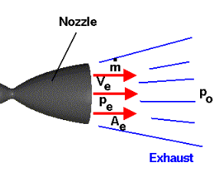

In a real model, the mass of the rocket gradually changes, since the depletion of fuel in the engine tank gets ejected. This makes sense since there is a change in momentum with time, therefore there is a mass flow rate, which is the change in mass with time. This change is mass depends on the density of the gas fuel, the velocity and the area covered in the throat of the nozzle.

$$\dot{m}=ρvA$$

* Unit: mass/time = kg/second
* ρ = density of fluid
* v=velocity of fluid gas
* A=area covered in the throat of nozzle

Having this formula, the distinction between me and mo is made, where me is the mass of fuel once it exists the rocket and mo is the mass of the fuel inside the tank, before it gets ejected. Now the new thrust formula can be derived resulting into:

$$F=\dot{m_{e}}v_{e}-\dot{m_{o}}v_{o}+(p_{e}-p_{o})A_{e}$$

where Pe > Po, meaning there is a pressure difference between the tank fuel and the atmosphere. This model mostly works for certain rockets. Since the engine turbines in rockets are designed in such a way where the exit pressure is the same as the atmospheric pressure, the difference becomes zero, resulting to:

$$F=\dot{m_{e}}v_{e}-\dot{m_{o}}v_{o}$$

Tracing back to the ideal model where mass does not change, the derivation results into:

$$F=-{m(v}_{e}-v_{o})$$

**3.1.4 Drag (Frictional) Force**

On Earth, frictionless objects do not exist. Friction is the force that is caused when an object moves on a surface. Friction consists of other types of forces, such as drag and fluid resistance. In rockets, drag force is the force caused by the resistance of the air or other gas fluids acting opposite to the motion of the object. This only exists when a solid is in contact with a liquid or a gas layer.

$$D= C_{d}\frac{ρv^{2}}{2}A$$

* Drag = coefficient x density of fluid x velocity squared x reference area x 0.5
* Coefficient Cd is not constant and is determined experimentally. Contains complex dependencies
* Reference Area: Affects the coefficient and can be chosen. Usually it’s the area projected by the frontal cone of the rocket.

This formula does not really have a derivation but it is rather found experimentally. The coefficient is not constant and it depends on other factors such as material, shape and pressure. The squared velocity indicates the proportionality with the drag force. In a graph of Drag force vs velocity, a parabolic line will occur. It also has to do with the potential flow of an object, which is the curling of the flow on the object. Furthermore, it is assumed that the density of air is constant throughout the flight. In reality, as the rocket flies higher, the air becomes less dense. To simplify calculations and minimize complexities, the difference is negligible, therefore density of air is treated as a contant. Again, this formula is usually considered a definition from experimentation and there are other drag force formulas for different objects. For rockets and airplanes, this specific formula is widely and commonly used.

**Lift-Induced drag:**

Lift-Induced drag is a drag force that changes the direction of the air flow. In aerodynamics, gravity and drag are two components that have to be overcome by any flying objects, such as rockets and aircrafts. Drag is different from other friction forces because it depends mostly on velocity, but it other components like density of air and referenced area of the object. This means, the shape and design of the rockets also play role in drag.

**Area effect on Drag:**

The more aerodynamic the rocket is, the smaller the drag. This means that the drag force depends on the side of the rocket. The reference area can be chosen. In this case, since we’re labeling the drag force as a resistance force, the area that should be chosen is the frontal area of the rocket. This is why rockets have a cone shaped frontal part so the airflow will be smooth, causing less air drag and smaller redirection of air. Since the frontal area is considered to be a circle, a rocket must have a small diameter compared to its lateral body height.

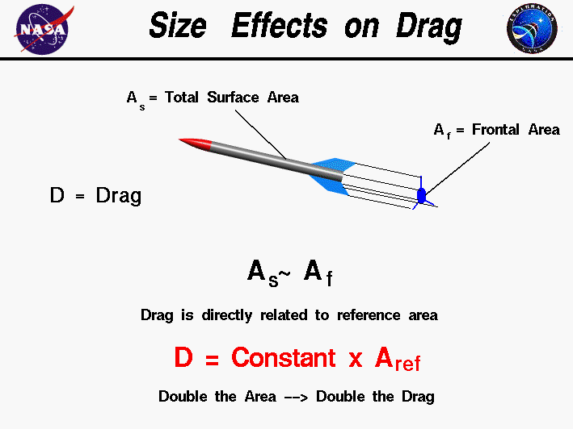

A simple object’s Full Body Diagram when on top of surface. (Taken from NASA.com)

The higher the velocity and the greater the density of the fluid medium is, the greater the drag force will be exerted. Since the object is moving fast, the air will attempt to resist the movement by pushing it backwards. Also, the density of the fluid can change the drag force. The more particles per unit of volume a medium has, the greater the resistance of the medium will be. If two rockets were to be fired, one from water and one from air, the one on water would move slower, due to the higher density of particles that creates greater resistances.

**3.1.5 Lift Force**

Although lift is usually confused with normal force, they are not the same. In an aircraft, lift acts opposite to the weight and is perpendicular to the flow of the air towards the solid or else, perpendicular to the direction of motion. In a rocket, lift is generated by the wings. Since lift force is generated between a fluid and a solid, lift force does not exist in space. In space, a rocket must have left and right propellants in order to steer to a desirable angle.

Normal force is usually confused with lift. Normal force is applied when a body is on a surface. If a rocket is launched from the ground, there is no normal force. Lift force is the force that keeps the object on a steady flying state, resisting the gravitational force.

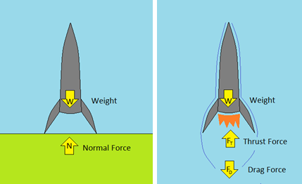

Rocket states: resting vs lifting, note: normal force only applies when the rocket is at rest on top of a surface. Image taken from: <https://www.teachengineering.org/lessons/view/cub_mars_lesson04>

In general, to make a realistic free body diagram of a rocket, the following forces must be under consideration:

* **Weight**
* **Normal (if on surface)**
* **Thrust**
* **Drag**
* **Lift**

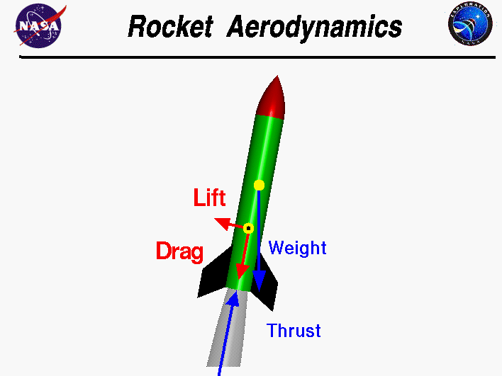

A rocket’s realistic Full Body Diagram (picture taken from NASA’s Educational site)

* 1. ***Kinematics of Rocket Trajectory:***

Since the forces of a rocket have been defined, their applications can be used to analyze and predict the motion of a rocket. Velocity, time, distance, height and acceleration are arguments that are either measured or calculated. Mass is not considered part of this branch of classical mechanics. The basic XY plane is used as the frame for the visualization of projectiles of a body. In forces, mostly the equations have no sophisticated derivations because they are just definitions, basic laws. Kinematics are calculations and formulas that are derived from basic principles.

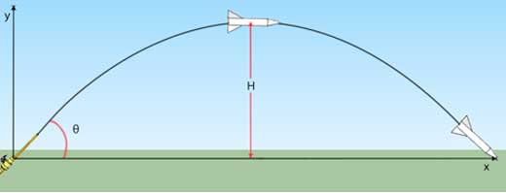

A ballistic rocket’s projectile path (Taken from: http://www.scienceinschool.org/2012/issue22/rockets)

**3.2.1 First Equation**

The main principle of kinematics is the definition of velocity, the change of displacement with respect to time:

$$v_{ave}=\frac{∆x}{∆t}$$

* Vave= average velocity
* X= displacement
* T= time interval, change in time

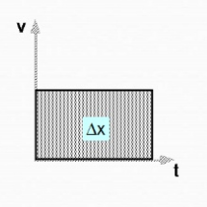

* Following diagrams taken from website: https://www.slideshare.net/omar_egypt/derivation-of-kinematic-equations (credits given to: omar_egypt)

This can change into the first basic equation:

$$∆x=v_{ave}∆t$$

This is when there is no acceleration. This formula is used for the horizontal X-axis, since the velocity remains constant. When acceleration is uniform, new terms are added, explaining the relation of initial and final velocities. This case occurs in the Y-axis, where velocity varies, therefore giving the first kinematics equation:

$$V_{f}=V_{i}+at$$

* Vi= Initial velocity at beginning of time interval
* Vf= final velocity at end of time elapsed
* A= slope, acceleration of rocket on Y axis
* t=time elapsed

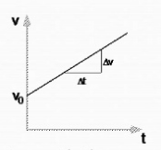

**3.2.2 Second Equation**

This was the derivation of the first kinematics equation. It can be used when time is known. The area under the line represents the displacement during the time interval. We can create a new relation, where the area under the line on the graph is the displacement. Having a triangular area shape:

$$∆x=\frac{∆v∆t}{2}$$

And from slope of V vs. t graph, the acceleration, the equation of the line is:

$$∆v=a∆t$$

If we substitute ∆v with the triangle relation, we derive a new formula. This new formula has an initial velocity of 0 m/s.

$$∆x=\frac{1}{2}at^{2}$$

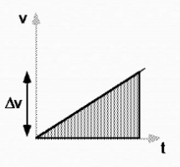

If initial velocity is not zero, a new distance is added to the formula, thus, a new area section is added to the graph.

(2)

$$∆x=V_{i}t+\frac{1}{2}at^{2}$$

The area of the interval will become greater, resulting to greater displacement.

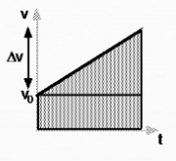

* Sum of two area under the line=displacement

**3.2.3 Third Equation**

This was the derivation of the second kinematics equation (2), having the arguments: initial and final velocities, time and acceleration. Note: 3 arguments must be known in order to be able to use the kinematics formulas. Usually, the acceleration and the initial velocities are known and the displacement is the variable needed to be calculated.

As we mentioned earlier, the average velocity is the change in displacement over the change in time. There is another way of expressing the average velocity using the mean formula:

(A)

$$V=\frac{V_{f}-V_{i}}{2}$$

* Vf-Vi is also ∆V

Since we know acceleration is the change in average velocity with the change in time, we can derive a new equation with respect to time:

(B)

$$∆t=\frac{V_{f}-V_{i}}{a}$$

Now taking into account the first equation of displacement mentioned in the beginning, we can substitute for average velocity and time using equations A and B resulting to the equation:

$$d=∆x=\frac{{V_{f}}^{2}-{V_{i}}^{2}}{2a}$$

Time gets cancelled with the multiplication of A and B that equal to displacement d or ∆x

This can be rearranged, bringing the velocities on one side and acceleration and displacement on the other. This is the second equation of kinematics on the Y-axis:

(3)

$$V_{f}^{2}-V_{i}^{2}=2ad$$

This third kinematics equation is mostly used when the time elapsed during the rocket’s flight cannot be calculated or it is not part of the three given variables.

In general, there are different equations that can be used. Keep in mind, depending on what frame is being used, there are different equations for constant velocity and uniform acceleration. When constant velocity, the X-axis is being considered as part of the frame. When uniform acceleration, the Y-axis is being considered as part of the frame.

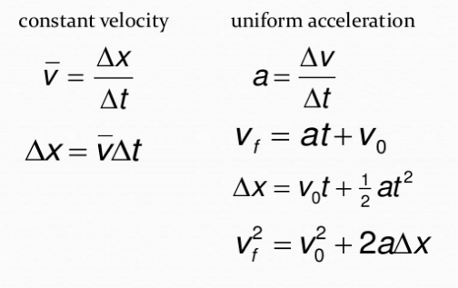

* Equations for Horizontal (constant velocity) and Vertical (uniform acceleration) components
  1. ***Tsiolkovsky (Ideal) Rocket Equation***

While rockets are on air accelerating, mass is being reduced not just from disconnecting parts, but from the burning of fuel. This results in a gradual loss of mass as well. In general, both the velocity and the mass chance over time, therefore there is a change in momentum with time. When the rocket accelerates, fuel is being burned resulting in decrease of mass.

Consider this ideal system, where gravity and air drag are ignored:

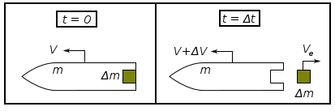

The first system illustrates the rocket before the fuel is burned and the second system illustrates when fuel is being burned and exiting the rocket’s tank fuselage. On the first system, there is conservation of momentum (Newton’s law): mass and velocity remain the same, therefore momentum remains constant and there is no acceleration, thus:

$$Σ\vec{F}=\vec{0} Σ{\vec{p}}_{i}=Σ{\vec{p}}_{f}$$

In the second system, there is a change in momentum, thus velocity and mass change as well with time. This implies that as the rocket accelerates, its mass decreases.

$$Σ\vec{F}=\frac{d(\vec{p})}{dt}=\frac{d(m\vec{v})}{dt}=m\frac{d\vec{v}}{dt}+\frac{dm}{dt}\vec{v}$$

Redefining terms:

$$Σ\vec{F}=\lim_{∆t→∞}{\frac{ρ_{2}-ρ_{1}}{∆t}}$$

At t=0, the momentum p1 has constant mass and velocity:

$$ρ_{1}=\left(m+∆m\right)v$$

where m is the mass of the rocket itself, ∆m is the mass of the fuel at the exhaust, m+∆m=mass of whole rocket at t=0 and v is the velocity of the rocket at t=0. At t=∆t, the gas fuel exits the rocket, splitting the mass into two parts while the rocket is accelerating. This leads to the definition of the momentum of p2:

$$ρ_{2}=m\left(v+∆v\right)+∆mV_{e}$$

* *M= mass of rocket*
* *V+∆v= velocity of rocket at t=∆t (Note: velocity is bigger than the velocity at t=0, implying the acceleration done by the rocket)*
* *∆m= mass of fuel at the exhaust*
* *Ve= velocity of fuel exiting from the exhaust, separating from the rocket.*

P2 is split into two components: the first part is the momentum of rocket and the second part is the momentum of the fuel existing the rocket. Now there are two frames of the velocity of the exiting frame: the observer’s and the rocket’s frames. A relation can be expressed between these two frames, where the difference of the rocket’s velocity with the rocket’s frame velocity gives the velocity of the exiting fuel by the observer:

$$V_{e}=v-v_{o}$$

* Vo=velocity of exiting fuel by the rocket’s frame

Now going back to the original equation, p1 and p2 will be substituted with their given definitions and Ve will be substituted with its frame related equation:

$$ρ_{2}-ρ_{1}=mΔV-v_{o}∆m$$

Since there is a change in velocity and mass, the terms Δv and Δm will be replaced with dv and –dm respectively. It is noted that dv is positive due to the accelerating pace of the rocket and –dm is negative due to the decrease in mass with time. Replacing these terms:

$$Σ\vec{F}=\frac{d(\vec{p})}{dt}=m\frac{d\vec{v}}{dt}+\vec{v_{o}}\frac{dm}{dt}$$

According to Newton’s conservation of linear momentum, if there are no external forces reacting to the rocket, the momentum remains constant. Using this law:

$$\frac{d\vec{ρ_{1}}}{dt}=-\frac{d\vec{ρ_{2}}}{dt} \frac{d\left(\vec{ρ_{1}}+\vec{ρ_{2}}\right)}{dt}=0$$

it will be stated that the sum of all forces equal to zero. Replacing Newton’s law with the rocket’s terms, we derive the following:

$$m\frac{d\vec{v}}{dt}=-\vec{v_{o}}\frac{dm}{dt}$$

It is assumed that Vo is constant, therefore the rocket fuel exists the exhaust in constant velocity (although it is highly unlikely it occurs in a realistic model), it is usually negligible and causes no major changes to the system. Knowing this, we integrate the equation. But before we set up the integration, we rearrange the variables by bringing the mass on the other side:

$$\frac{dv}{dt}=-\vec{\frac{v_{o}}{m}}\frac{dm}{dt}$$

Now we set up the integration for the change in mass from mi to mf and the change in velocity from vi tovf:

Now we integrate and get:

$${Δv=v}_{f}-v_{i}=v_{o} ln\left(\frac{m_{i}}{m_{f}}\right)$$

* Mi=Initial Rocket total mass
* Mf=final rocket total mass after burnout
* Vo=effective exhaust velocity
* Δv=change of velocity when t=Δt, when no external forces act on the rocket

This equation provides the ideal representation of a rocket’s momentum in space, but it is not fully realistic due to the assumption of conservation of momentum, meaning external forces such as drag force do not affect the movement of the rocket. In more advanced models, external reactions are added to the equation, creating more complex algorithms that are used for realistic simulations and real life rockets. In general, the Tsiolkovsky equation can be derived using other methods such as energy. In this comprehensive assessment, the equation was derived using Newton’s Law.

According to NASA’s commentary on the rocket equation, it is described as a “tyranny” due to the amount of fuel needed for a rocket to be lifted. The Saturn V rocket used an incredible amount of fuel. The fuel propellant took up 85% of the total mass of Saturn V before its launch phase. Once it escaped the atmosphere, the rocket lost 90% of its total mass since launch phase, while its payload dropped was only less than 5%. Rockets of course are limited and a balance between mass and propellant have to be precisely calculated and examined. NASA’s and SpaceX’s mission is to provide lightweight and affordable trips to space. Minimizing mass, cost and fuel use, trips on Mars and on the Moon will be more common than ever. SpaceX is working on reusable rockets in order to cut down fuel consumption by a large percentage and minimize the cost and resources needed for trips to space.

1. ***CONCLUSION***

The purpose of this assessment was to analyze a rocket’s interaction with space using Classical Mechanics as the primary method. Once the basic and simple concepts are demonstrated, more complex and in-depth information are added, such as the rocket’s burning fuel performance and the projectile movement.

Starting with forces, a rocket has to overcome external and natural reactions. Therefore, it has to produce its own forces, thrust and lift in order to overcome gravity and drag. The gravitational force pulls the rocket’s body to the ground at an acceleration 9.8m/s2. If the rocket is not launched yet and is resting on its launch pod, a normal force is applied which its vertical component is equal and opposite of gravitational force, meaning the rocket does not move and has a net force of zero Newtons. When the engine of the rocket is activated, a new force appears, the thrust force. This force pushes and moves the rocket. Once the rocket gets off the launching settlement, the air creates a resistance that slows down the rocket. This is called the drag force, where the fluid the solid rocket interacts with pushes it back. The greater the rocket’s speed, the greater the resistance, therefore the thrust force must become greater than drag in order to push forward. When a rocket is moving, the air flow creates a new force, the lift force. Lift stabilizes the rocket’s movement. Plotting all these forces in a diagram, the direction of a rocket’s movement can be determined and the magnitude of the net force that pushes it.

A rocket’s position and velocity can be tracked on a time interval. Kinematic equations facilitate the rocket’s calculations of its projectile path. If the rocket does not turn by itself, it uses gravity to turn, resulting in a projectile path that either ends on the Earth’s surface or at the atmosphere. If time is known, two equations can be used which are: Vf=Vi+at and d=Vi+0.5at2. If time is unknown, but distances are, the following formula is used: Vf2-Vi2+2ad, where V is the velocity of object, a is downward acceleration and d is the height of the object.Either way, with these calculations, the path of the rocket can be predicted.

In reality, mass on a rocket does not remain the same throughout its flight. Payloads and fuel tanks are being dropped at certain stages, but the rocket loses mass from the beginning of its operation. By time elapsing, the rocket burns fuel and gets ejected from the rocket exhaust. Tsiolkovsky’s derived rocket equation can determine the mass of a rocket at a certain velocity interval while it accelerates. As it turns out rockets are not very efficient for space travelling due to the amount of fuel and mass needed to propel into space. The cost is insanely high and current space rockets are only used once, like a military missile. Once it launches and completes its path, the rocket is being torn apart. NASA, SpaceX and other companies are working on creating rockets that can be reused.

***Epilogue:***

Rockets are the leading inventions of the modern world’s technology. They are used for massive projects and are really dangerous if used incorrectly. They must be controlled with caution in order to minimize the possibilities of any accidents or failures. Whether it is a military rocket missile or a space rocket, the process of engineering them is tedious, long and complicated. A simple mistake can result in brutal accidents, causing billions of dollars in damages and possibly the death of many. This is why the scientists working in the laboratories are experts and are aware of what they are doing. Mistakes, misunderstandings and miscalculations are intolerable. But this does not neglect the fact that mistakes will never happen. From accidents, new discoveries and solutions can be derived, making sure failures will not happen again. Accidents may happen, rockets may fail to operate, but ceasing all work completely and never improving the rocket industry, space exploration will never occur again.

1. ***REFERENCES (WEBSITES AND BOOKS)***

Dunbar, Brian. "What Is a Rocket?" *NASA*. Ed. Sandra May. NASA Knows!, 20 May 2015. Web. 20 Feb. 2017. <https://www.nasa.gov/audience/forstudents/k-4/stories/nasa-knows/what-is-a-rocket-k4.html>.

Schupak, Amanda. "How to Launch a Rocket into Space in 5 (...4...3...2...1) Steps." LiveScience. Purch, 25 July 2011. Web. 23 Feb. 2017. <http://www.livescience.com/33410-how-to-launch-rocket-space.html>.

"Get Me Off This Planet - Lesson." TeachEngineering. University of Colorado Boulder, n.d. Web. 23 Feb. 2017. <https://www.teachengineering.org/lessons/view/cub_mars_lesson04>.

Wood, David. "Gravitational Force: Definition, Equation & Examples." Study.com. BBB, n.d. Web. 5 Apr. 2017. <http://study.com/academy/lesson/gravitational-force-definition-equation-examples.html>.

"What is normal force?" Khan Academy. N.p., n.d. Web. 25 Apr. 2017. <https://www.khanacademy.org/science/physics/forces-newtons-laws/normal-contact-force/a/what-is-normal-force>.

NASA. “What is Thrust?”. Ed. Nancy Hall. NASA, 05 May 2015. Web. 19 Apr. 2017. <https://www.grc.nasa.gov/www/k-12/airplane/thrust1.html>.

"Thrust." Wikipedia. Wikimedia Foundation, 05 Feb. 2002. Web. 19 Apr. 2017.

"The Drag Equation." NASA. Ed. Tom Benson. NASA, 12 June 2014. Web. 21 Apr. 2017. <https://spaceflightsystems.grc.nasa.gov/education/rocket/drageq.html>.

Aaron, Kim, Dr. "How was the drag force equation, 1/2Cdpsv^2, derived?" Quora. N.p., 15 Apr. 2016. Web. 21 Apr. 2017. <https://www.quora.com/How-was-the-drag-force-equation-1-2Cdpsv-2-derived>.

"Size Effects on Drag." NASA. Ed. Tom Venson. NASA, 12 June 2014. Web. 21 Apr. 2017. <https://spaceflightsystems.grc.nasa.gov/education/rocket/sized.html>.

"Rocket Aerodynamics." NASA. Ed. Tom Benson. NASA, 12 June 2014. Web. 21 Apr. 2017. <https://spaceflightsystems.grc.nasa.gov/education/rocket/rktaero.html>.

"Kinematics." Wikipedia. Wikimedia Foundation, 26 Sept. 2005. Web. 23 Apr. 2017. <https://en.wikipedia.org/w/index.php?title=Kinematics&dir=prev&action=history>.

Omar_egypt. "Derivation of Kinematic Equations." LinkedIn SlideShare. N.p., 15 Oct. 2014. Web. 23 Apr. 2017. <https://www.slideshare.net/omar_egypt/derivation-of-kinematic-equations>.

"Tsiolkovsky Rocket Equation." Wikipedia. Wikimedia Foundation, 13 Oct. 2004. Web. 25 Apr. 2017. <https://en.wikipedia.org/wiki/Tsiolkovsky_rocket_equation>.

Admin. "Tsiolkovsky Rocket Equation." Talkchannels. N.p., 16 Feb. 2016. Web. 25 Apr. 2017. <http://www.talkchannels.com/tsiolkovsky-rocket-equation/>.

"Ideal Rocket Equation." NASA. Ed. Tom Benson. NASA, 12 June 2014. Web. 07 May 2017. <https://spaceflightsystems.grc.nasa.gov/education/rocket/rktpow.html>.

“Aerospace Science and Technology”. Ed. J. A. Ekaterinaris. Vol. 64. N.p.: n.p., 2017. 204-12. Print.